Design Flow:
- UI
- Business Logic
- Data Logic
- Custom Controls
- Dependencies
- WORK FLOW ( View -> Controller -> Model -> Entity )
Code Flow:
- UI design pattern – (HTML, Scripts)
- Coding standard and guidelines (Controller, business logic and data access)
Database objects & Schema:
- Database
- Table – Purpose, ER diagram, Model class
- Procedure, Functions, view , custom type
Backlog:
Sort Description | Detailed Description | Effort | Type (Functional/Technical) | Requested By

Created Date | Created by | Review Date | Review by

Login UI:
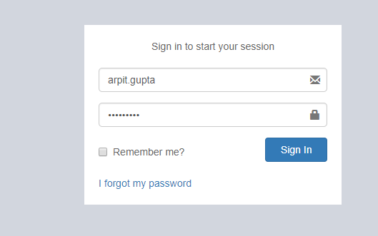

Business Logic and Module: We use Microsoft Asp.net Identity 2.0 Feature for Login Credential.
Click on Sign in Button → Open below Screen shot (SiteSelection Page).
Dependencies: Microsoft Asp.net Identity 2.0 (Only for login)

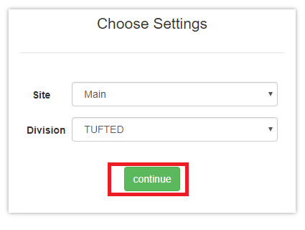Screen Shot no.1

Business Logic:
1: Controller Name -> SiteSelectionController: SiteSelection controller has seven services for use.
- ISiteSelectionService
- IUserRolesService
- ImoduleService
- IUserBookMarkService
- ICompanySettingsService
- ICompanyService
- IRolesControllerActionService
Action Method -> SiteSelection: To display site selection screen we use GetUserId method of SiteSelection controller and after that we identify for particular Roles.
Below Methods are given for User Role and Roles list.
- GetUserRolesList()
- GetRolesList()
To bind dropdown list we use below method.
- GetSiteList()
- GetDivisionList()
Data Logic→ 1: For Roles.
View Model Name/Model: UserRoleViewModel, UserRole, UserProfile, UserReferral:
In this View Model and Model we declare all property related to roles.
2: For Site & Division.
View Model Name/Model: Site/ Division
In this view model and model we declare all property related site and Division.
Entity Framework/Services->1: for Roles
Services Name: UserService: In this service has GetUserRolesList ()
In which is define in UserReferralService interface.
2: For Site & Division
Service Name: SiteService: In this service has GetSiteList () in which is define in SiteService interface.
DivisionService: In this service has GetDivisionList () in which is define in
DivisionService interface.
Dependencies:
Data Access Layer
(UserService & SiteService & DivisionService)

Business Logic
(SiteSelection Controller)

Presentation Layer (View layer)
(SiteSelection.chtml)

Work Flow: View → Controller →Model
View: SiteSelection.chtml -> clearly we can see design of page in screen shot no .1
Controller: SiteSelectionController
Model: UserRoleViewModel, UserRole, UserProfile and UserReferral

Database (Table/Stored procedure /View):
1. | Web.Menus
MenuId | INT IDENTITY NOT NULL, | PRIMARY KEY
MenuName | NVARCHAR (50) NOT NULL,
Srl | NVARCHAR (5) NOT NULL,
IconName | NVARCHAR (100) NOT NULL,
Description | NVARCHAR (100) NOT NULL,
ModuleId | INT NOT NULL,
SubModuleId | INT NOT NULL,
ControllerActionId | INT NOT NULL,
RouteId | NVARCHAR (max),
IsActive | BIT DEFAULT ((1)) NOT NULL,
CreatedBy | NVARCHAR (max),
ModifiedBy | NVARCHAR (max),
CreatedDate | DATETIME NOT NULL,
ModifiedDate | DATETIME NOT NULL,
URL | NVARCHAR (100),
IsVisible | BIT,
isDivisionBased | BIT DEFAULT ((0)),
isSiteBased | BIT DEFAULT ((0)),
AreaName | NVARCHAR (50),
ControllerName | NVARCHAR (100),
ActionName | NVARCHAR (100),

2. | Web.RolesMenus
RolesMenuId | INT IDENTITY NOT NULL, | PRIMARY KEY
RoleId | NVARCHAR (128),
MenuId | INT NOT NULL,
CreatedBy | NVARCHAR (max),
ModifiedBy | NVARCHAR (max),
CreatedDate | DATETIME NOT NULL,
ModifiedDate | DATETIME NOT NULL,
FullHeaderPermission | BIT DEFAULT ((0)) NOT NULL,
FullLinePermission | BIT DEFAULT ((0)) NOT NULL,
DivisionId | INT DEFAULT ((1)) NOT NULL,
SiteId | INT DEFAULT ((17)) NOT NULL,

3. | Web.Sites
SiteId | INT IDENTITY NOT NULL, | PRIMARY KEY
SiteName | NVARCHAR (50) NOT NULL,
Address | NVARCHAR (250),
PhoneNo | NVARCHAR (50),
CityId | INT,
IsActive | BIT DEFAULT ((1)) NOT NULL,
IsSystemDefine | BIT DEFAULT ((0)) NOT NULL,
CreatedBy | NVARCHAR (max),
ModifiedBy | NVARCHAR (max),
CreatedDate | DATETIME NOT NULL,
ModifiedDate | DATETIME NOT NULL,
OMSId | NVARCHAR (50),
SiteCode | NVARCHAR (20),
DefaultDivisionId | INT,
ThemeColour | NVARCHAR (25),
PersonId | INT,
DefaultGodownId | INT,
DocTypeId | INT,
SiteShortCode | NVARCHAR (2),

4. | Web.RolesSites
RolesSiteId | INT IDENTITY NOT NULL, | PRIMARY KEY
RoleId | NVARCHAR (128),
SiteId | INT NOT NULL,
CreatedBy | NVARCHAR (max),
ModifiedBy | NVARCHAR (max),
CreatedDate | DATETIME NOT NULL,
ModifiedDate | DATETIME NOT NULL,

5. | Web.Divisions
DivisionId | INT IDENTITY NOT NULL, | PRIMARY KEY
DivisionName | NVARCHAR (50) NOT NULL,
Address | NVARCHAR (250),
LstNo | NVARCHAR (20),
CstNo | NVARCHAR (20),
IsActive | BIT DEFAULT ((1)) NOT NULL,
IsSystemDefine | BIT DEFAULT ((0)) NOT NULL,
CreatedBy | NVARCHAR (max),
ModifiedBy | NVARCHAR (max),
CreatedDate | DATETIME NOT NULL,
ModifiedDate | DATETIME NOT NULL,
OMSId | NVARCHAR (50),
CompanyId | INT,
ThemeColour | NVARCHAR (25),
ReportHeaderTextRight1 | NVARCHAR (max),
ReportHeaderTextRight2 | NVARCHAR (max),
ReportHeaderTextRight3 | NVARCHAR (max),
ReportHeaderTextRight4 | NVARCHAR (max),
DivisionShortCode | NVARCHAR (2),
LogoBlob | NVARCHAR (max),

6 | Web.RolesDivisions
RolesDivisionId | INT IDENTITY NOT NULL, | PRIMARY KEY
RoleId | NVARCHAR (128),
DivisionId | INT NOT NULL,
CreatedBy | NVARCHAR (max),
ModifiedBy | NVARCHAR (max),
CreatedDate | DATETIME NOT NULL,
ModifiedDate | DATETIME NOT NULL,

Selection of Godown-> In Screen shot no.1, click on →Continue Button →open Below Screen.
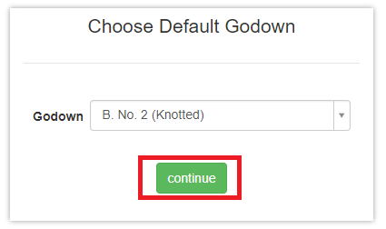
(Screen Shot no.2)
Business logic -> Controller Name: SiteSelectionController
Action Method: DefaultGodownSelection: To display Godown screen we use GetGodownList () function of SiteSelectionController.
To bind the Godown dropdown list using below method.
GetGodownList (): This function is define in IGodownService services.
Data Logic->
View Model Name/Model: Godown.cs
Entity Formwork / Services→
Service Name: ISiteSelectionService, ICompanySettingsService, IGodownService.
Dependencies:
Data Access Layer
(IGodownService, ICompanySettingsService, ISiteSelectionService)

Business Logic
(SiteSelection Controller)

Presentation Layer (View layer)
(DefaultGodownSelection)

Work Flow: View → Controller →Model
View: DefaultGodownSelection.chtml
Controller Name: SiteSelectionController
Model Name: Godown.cs
Database (Table/Stored procedure /View):
 | Web.Godowns
GodownId | INT IDENTITY NOT NULL, | PRIMARY KEY
GodownName | NVARCHAR (50) NOT NULL,
SiteId | INT NOT NULL,
IsActive | BIT DEFAULT ((1)) NOT NULL,
CreatedBy | NVARCHAR (max),
ModifiedBy | NVARCHAR (max),
CreatedDate | DATETIME NOT NULL,
ModifiedDate | DATETIME NOT NULL,
OMSId | NVARCHAR (50),
Site_SiteId | INT,
GateId | INT,
DocTypeId | INT,
GodownCode | NVARCHAR (10),
PersonId | INT,

HUMAN RESOUCE UI:
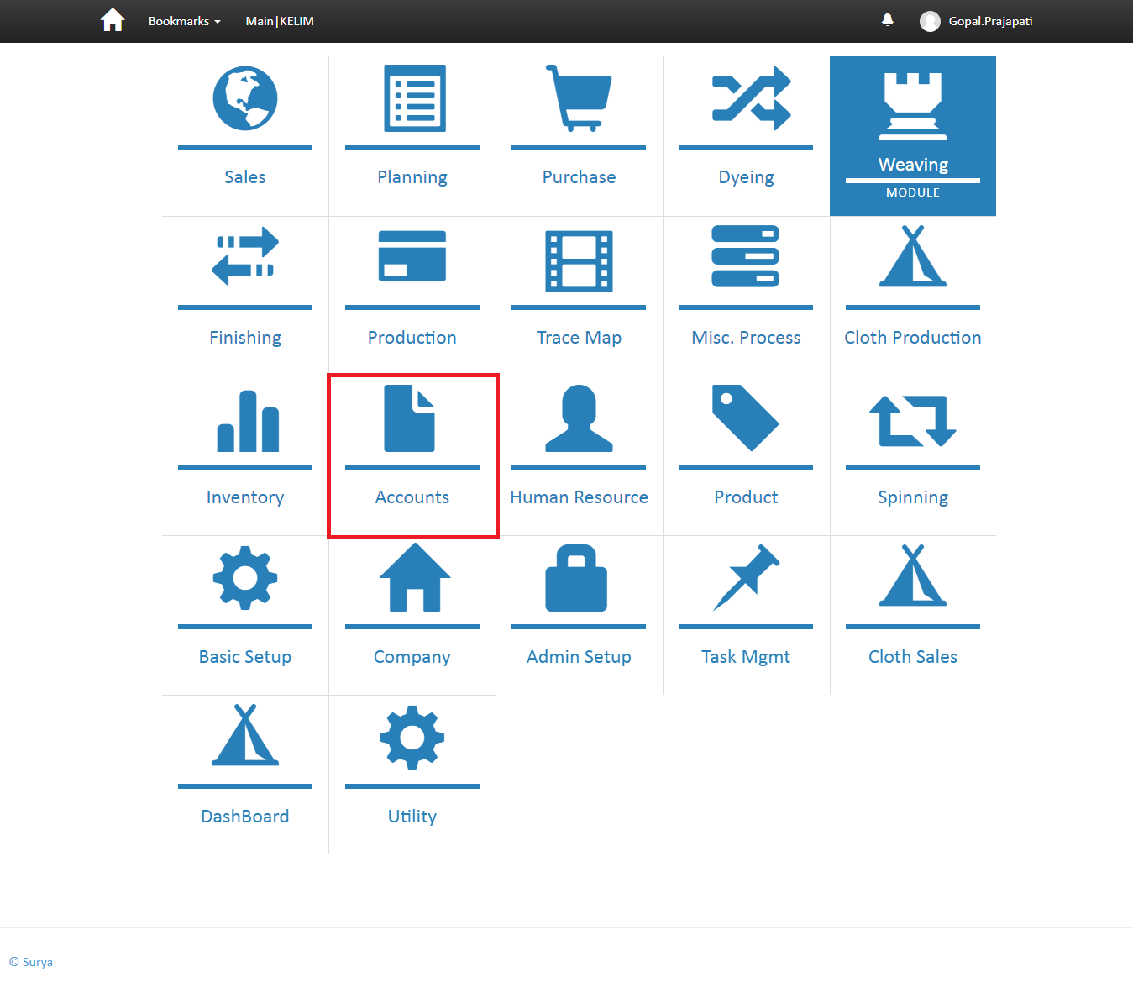
(screen shot No-03)
Business Logic:
Controller Name-> MenuController : Menu controller has three services for display menu
a)-IModuleService
b)-ISubModuleService
c)- IUnitOfWork
- Action Method-> Module: To display menu we use GetModules function of ImoduleService interface. In Module Action we stored all menu in Moduleslist variable and check condition if Moduleslist == 1 then open SubModule otherwise Module
Data Logic:
Model Name: MenuModouleViewModel.cs
Entity Framework/ Services: ImoduleService.cs ' In this Service we define
GetModules() .

Dependencies:

Data Access Layer
(Module services)

Business Logic
(menu Controller)
Presentation Layer (View layer)
(module.chtml)

 | web.menu module
Fields | DataType | Constrain | Remark
ModuleId | INT IDENTITY NOT NULL, | PRIMARY KEY
ModuleName | NVARCHAR (50) NOT NULL,
Srl | INT NOT NULL,
IconName | NVARCHAR (100) NOT NULL,
IsActive | BIT DEFAULT ((1)) NOT NULL,
CreatedBy | NVARCHAR (max),
ModifiedBy | NVARCHAR (max),
CreatedDate | DATETIME NOT NULL,
ModifiedDate | DATETIME NOT NULL,
URL | NVARCHAR (100),

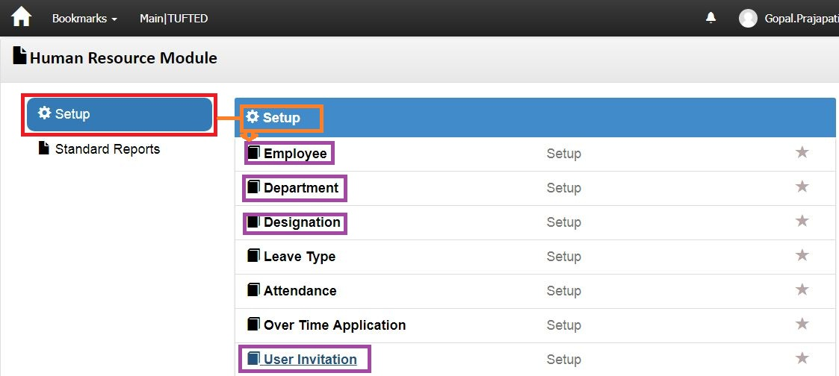 (Screen shot no-04)
Business Logic:
- Controller Name-> MenuController : Menu controller has three services for display menu
a)- IModuleService
b)-ISubModuleService
c)- IUnitOfWork
Action Method: Module: In this Action method we identify particular user Role and then execute GetModuleList () and GetModuleListForUser ().
Finally Return Module and SubModule View based on condition.
DataLogic-
ModelName- SubModuleViewModel.cs
Dependencies:
Data Access Layer
(SubModuleService)

Business Logic
(Menu Controller)

Presentation Layer (View layer)
(Submodule.chtml)

Work Flow: View → Controller →Model
View: Submodule.chtml -> clearly us can see design of page
Controller: Menu Controller
Model: MenuViewModel / SubModuleViewModel

Database (Table/Stored procedure/View)
 | web.MenuSubModules
Fields | DataType | Constrain | Remark
SubModuleId | INT IDENTITY NOT NULL, | PRIMARY KEY
SubModuleName | NVARCHAR (50) NOT NULL,
IconName | NVARCHAR (100) NOT NULL,
IsActive | BIT DEFAULT ((1)) NOT NULL,
CreatedBy | NVARCHAR (max),
ModifiedBy | NVARCHAR (max),
CreatedDate | DATETIME NOT NULL,
ModifiedDate | DATETIME NOT NULL,
OMSId | NVARCHAR (50),

Employee:->
Note: In Screen shot no. 04, DoubleClick on “Employee” Hyperlink →Open below Screen Shot.
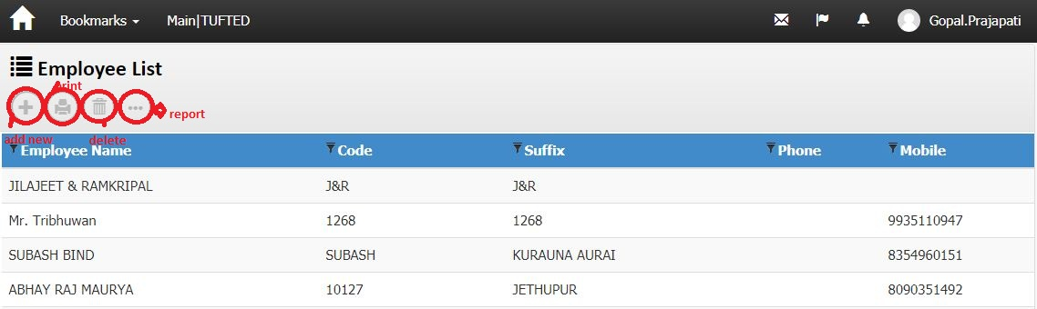
screenshotNo-05
Business Logic:

1)-Controller Name-> EmployeeController: This controller has three Services for display Employee voucher List.

a) IEmployeeService
b) IBusinessEntityService
c) IPersonService
d) IPersonAddressService
e) IAccountService
f) IPersonProcessService
g) IPersonRegistrationService
h) IActivityLogService
i) IUnitOfWork
j) IExceptionHandlingService
2)-Action Method:
Action Method Name :-> Index: In this Action we get Employee voucher list using GetEmployeeListForIndex () method of EmployeeController
3)-Entity Framework/Services->
Services Name: EmployeeService →In this services we define GetEmployeeListForIndex ().
DataLogic-
View Model Name/Model – Employee / EmployeeIndexViewModel
Dependencies:
Data Access Layer
(EmployeeService)

Business Logic
(EmployeeController)

Presentation Layer (View layer)
(Index.chtml)

Work Flow: View → Controller →Model
View: Index.chtml -> clearly us can see design of page
Controller: EmployeeController
Model: Employee / EmployeeIndexViewModel

Note: In Screen shot no.05, Double Click on “ gridview row of Employee list” Hyperlink →Open below Screen
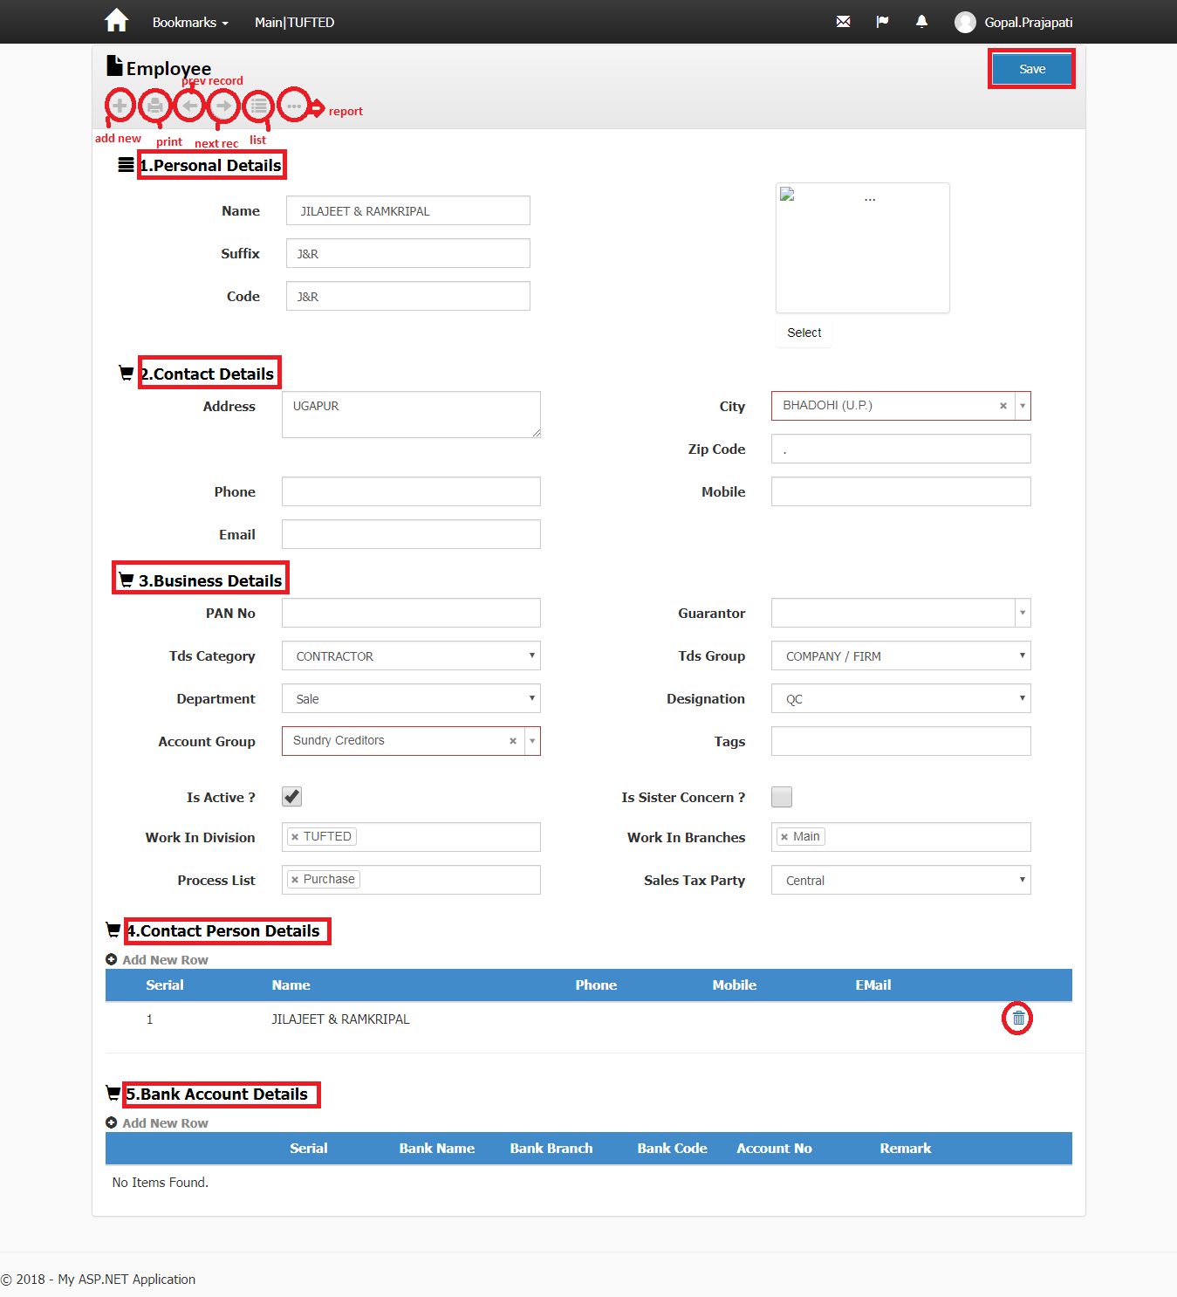
ScreenShotNo-06
Business Logic:

1)-Controller Name-> EmployeeController: This controller has three Services for display Employee voucher List.

a) IEmployeeService
b) IBusinessEntityService
c) IPersonService
d) IPersonAddressService
e) IAccountService
f) IPersonProcessService
g) IPersonRegistrationService
h) IActivityLogService
i) IUnitOfWork
j) IExceptionHandlingService
2)-Action Method:
Action Method Name :-> Edit: In this Action we get Employee using GetEmployeeViewModel () method of EmployeeController
3)-Entity Framework/Services->
Services Name: EmployeeService →In this services we define GetEmployeeViewModel ().
DataLogic-
View Model Name/Model – Employee / EmployeeIndexViewModel
Action Method for headers:
▪ NextPage () ' For Next page
▪ PrevPage ()' For Previous page
▪ Prints () ' For print.
▪ Save () for save record of header
▪ List () for index
▪ Add new () Create a new header row
▪ More option () for report

Dependencies:
Data Access Layer
(EmployeeService)

Business Logic
(EmployeeController)

Presentation Layer (View layer)
(Edit.chtml)

Work Flow: View → Controller →Model
View: Edit.chtml -> clearly us can see design of page
Controller: EmployeeController
Model: Employee / EmployeeIndexViewModel

Contact Person Detail :->
Business Logic:

1)-Controller Name-> PersonContactController: This controller has three Services for display Employee voucher List.
a).IPersonContactService
b).IPersonService
c).IUnitOfWork
d).IExceptionHandlingService
2)-Action Method:
Action Method Name :-> Index: In this Action we get contactpersonDetail using GetPersonContactListForIndex () method of PersonContactController
3)-Entity Framework/Services->
Services Name: IPersonContactService →In this services we define GetPersonContactListForIndex ().
DataLogic-
Postmethod-
1.CreatePost()
View Model Name/Model – PersonContactViewModel,PersonContact
Dependencies:
Data Access Layer
(PersonContactService)

Business Logic
((PersonContactController))

Presentation Layer (View layer)
((Index.cshtml))

Work Flow: View → Controller →Model
View: Index.chtml -> clearly us can see design of page
Controller: PersonContactController
Model: PersonContactViewModel, PersonContact

PersonBankAccount :->
Business Logic:

1)-Controller Name-> PersonBankAccountController: This controller has three Services for display BANK account detail.
a). IPersonBankAccountService
b). IPersonService
c). IUnitOfWork
d). IExceptionHandlingService
2)-Action Method:
Action Method Name :-> Index: In this Action we get contactpersonDetail using GetPersonBankAccountListForIndex () method of PersonBankAccountController
3)-Entity Framework/Services->
Services Name: IPersonBankAccountService →In this services we define GetPersonBankAccountListForIndex ().
Postmethod-
1._CreatePost ()
DataLogic-
Postmethod-
1. CreatePost ()
View Model Name/Model-PersonBankAccountViewModel,

Dependencies:
Data Access Layer
((PersonBankAccountService))

Business Logic
(PersonBankAccountController)

Presentation Layer (View layer)
((Index.cshtml))

Work Flow: View → Controller →Model
View: Index.chtml -> clearly us can see design of page
Controller: PersonBankAccountController
Model: PersonBankAccountViewModel,

Database (Table/Stored procedure/View)
1):-
Web.Employees
ColumnName | Datatype | ReferencedTable | ReferencedColumn
EmployeeId | int |  | PRIMARY
PersonID | int | Web.People | PersonID (FK)
DesignationID | int | Web.Designations | DesignationId (FK)
DepartmentID | int | Web.Departments | DepartmentId (FK)
OMSId | nvarchar
BasicSalary | decimal

2):-
Web.people
ColumnName | Datatype | ReferencedTable | ReferencedColumn
PersonID | int |  | primary
Name | nvarchar
Suffix | nvarchar
Code | nvarchar
Description | nvarchar
Phone | nvarchar
Mobile | nvarchar
Email | nvarchar
IsActive | bit
Tags | nvarchar
ImageFolderName | nvarchar
ImageFileName | nvarchar
CreatedBy | nvarchar
ModifiedBy | nvarchar
CreatedDate | datetime
ModifiedDate | datetime
OMSId | nvarchar
ApplicationUser_Id | nvarchar | Web.Users | Id (FK)
IsSisterConcern | bit
Nature | nvarchar
DocTypeId | int | Web.DocumentTypes | DocumentTypeId (FK)
Status | int
ReviewCount | int
ReviewBy | nvarchar

3):-
Web.BusinessEntities
ColumnName | Datatype | ReferencedTable | ReferencedColumn
PersonID | int | Web.People | PersonID (FK)
ParentId | int | Web.People | PersonID (FK)
TdsCategoryId | int | Web.TdsCategories | TdsCategoryId (FK)
TdsGroupId | int | Web.TdsGroups | TdsGroupId (FK)
GuarantorId | int | Web.People | PersonID (FK)
SalesTaxGroupPartyId | int
IsSisterConcern | bit
PersonRateGroupId | int | Web.PersonRateGroups | PersonRateGroupId (FK)
ServiceTaxCategoryId | int | Web.ServiceTaxCategories | ServiceTaxCategoryId (FK)
CreaditDays | int
CreaditLimit | decimal
DivisionIds | nvarchar
SiteIds | nvarchar
OMSId | nvarchar
Buyer_PersonID | int | Web.People | PersonID (FK)

4):-
Web.PersonAddresses
ColumnName | Datatype | ReferencedTable | ReferencedColumn
PersonAddressID | int |  | primary
PersonId | int | Web.People | PersonID (FK)
AddressType | nvarchar
Address | nvarchar
CityId | int | Web.Cities | CityId (FK)
AreaId | int | Web.Areas | AreaId (FK)
Zipcode | nvarchar
CreatedBy | nvarchar
ModifiedBy | nvarchar
CreatedDate | datetime
ModifiedDate | datetime
OMSId | nvarchar

5):-
Web.PersonProcesses
ColumnName | Datatype | ReferencedTable | ReferencedColumn
PersonProcessId | int |  | primary
PersonId | int | Web.People | PersonID (FK)
ProcessId | int | Web.Processes | ProcessId (FK)
CreatedBy | nvarchar
ModifiedBy | nvarchar
CreatedDate | datetime
ModifiedDate | datetime
OMSId | nvarchar
PersonRateGroupId | int | Web.PersonRateGroups | PersonRateGroupId (FK)

6):-
Web.PersonRegistrations
ColumnName | Datatype | ReferencedTable | ReferencedColumn
PersonRegistrationID | int |  | primary
PersonId | int | Web.People | PersonID (FK)
RegistrationType | nvarchar
RegistrationNo | nvarchar
CreatedBy | nvarchar
ModifiedBy | nvarchar
CreatedDate | datetime
ModifiedDate | datetime
OMSId | nvarchar
RegistrationDate | datetime
ExpiryDate | datetime

Department:->
Note: In Screen shot no. 04,DoubleClick on “Department” Hyperlink →Open below Screen Shot.
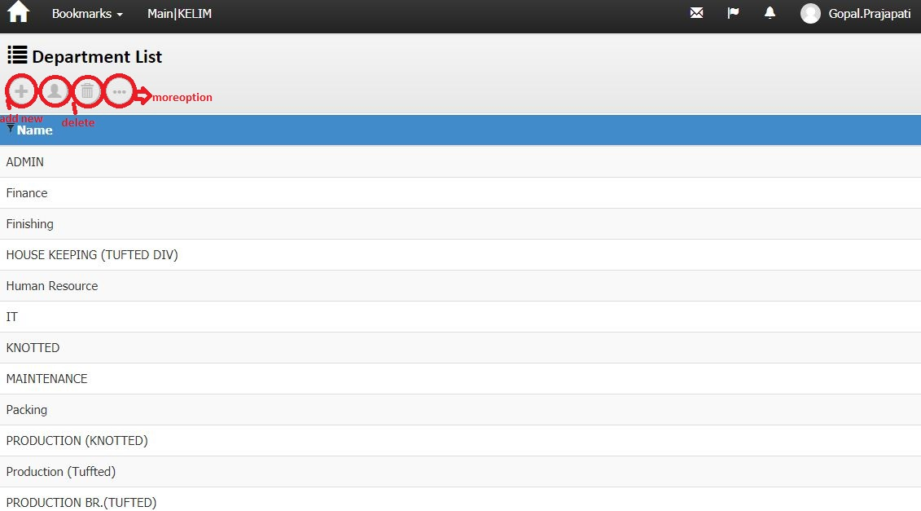
screenshotNo-07
Business Logic:

1)-Controller Name-> DepartmentController: This controller has three Services for display Department List.

a) IDepartmentService
b) IUnitOfWork
c) IExceptionHandlingService
2)-Action Method:
Action Method Name :-> Index: In this Action we get Department using GetDepartmentList () method of DepartmentController
3)-Entity Framework/Services->
Services Name: DepartmentService →In this services we define GetDepartmentList ().
DataLogic-
View Model Name/Model – Department
Dependencies:
Data Access Layer
(DepartmentService)

Business Logic
(DepartmentController)

Presentation Layer (View layer)
(Index.chtml)

Work Flow: View → Controller →Model
View: Index.chtml -> clearly us can see design of page
Controller: DepartmentController
Model: Department

Note: In Screen shot no.07, Double Click on “ gridview row of Department list” Hyperlink →Open below Screen
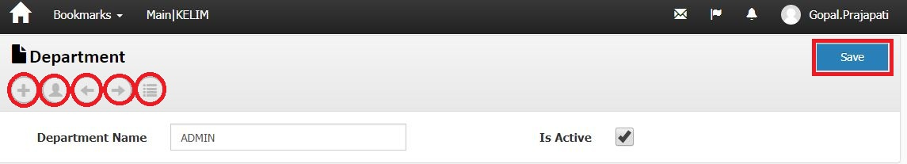
ScreenShotNo-08
Business Logic:

1)-Controller Name-> DepartmentController: This controller has three Services for display Depatment.

a) IDepartmentService
b) IUnitOfWork
c) IExceptionHandlingService
2)-Action Method:
Action Method Name :-> Edit: In this Action we get Department using Find () method of DepartmentController
3)-Entity Framework/Services->
Services Name: _DepartmentService →In this services we define Find ().
DataLogic-
View Model Name/Model – Department
Action Method for headers:
▪ NextPage () ' For Next page
▪ PrevPage ()' For Previous page
▪ Save () for save record of header
▪ List () for index
▪ Add new () Create a new header row
History() for detail(history)

Dependencies:
Data Access Layer
(DepartmentService)

Business Logic
(DepartmentController)

Presentation Layer (View layer)
(Edit.chtml)

Work Flow: View → Controller →Model
View: Edit.chtml -> clearly us can see design of page
Controller: DepartmentController
Model Department

Database (Table/Stored procedure/View)
Web.Department
ColumnName | Datatype | ReferencedTable | ReferencedColumn
DepartmentId | int |  | primary
DepartmentName | nvarchar
IsActive | bit
CreatedBy | nvarchar
ModifiedBy | nvarchar
CreatedDate | datetime
ModifiedDate | datetime
OMSId | nvarchar

Designation:->
Note: In Screen shot no. 04, DoubleClick on “Designation” Hyperlink →Open below Screen Shot.
screenshotNo-09
Business Logic:

1)-Controller Name-> DesignationController: This controller has three Services for display Designation List.
a) IDesignationService
b) IUnitOfWork
c) IExceptionHandlingService
2)-Action Method:
Action Method Name :-> Index: In this Action we get Designation using GetDesignationList () method of DesignationController
3)-Entity Framework/Services->
Services Name: DesignationService →In this services we define GetDepartmentList ().
DataLogic-
View Model Name/Model – Designation
Dependencies:
Data Access Layer
(DesignationService)

Business Logic
(DesignationController)

Presentation Layer (View layer)
(Index.chtml)

Work Flow: View → Controller →Model
View: Index.chtml -> clearly us can see design of page
Controller: DesignationController
Model: Designation

Note: In Screen shot no.09, Double Click on “ grid view row of Designation list” Hyperlink →Open below Screen
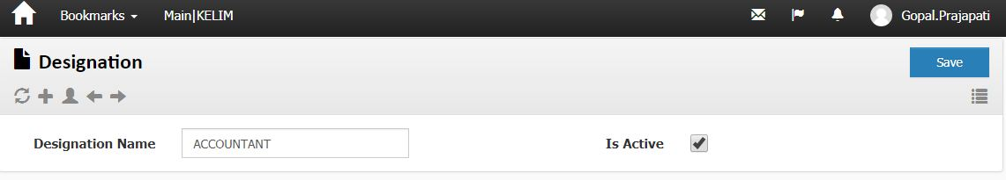
ScreenShotNo-10
Business Logic:

1)-Controller Name-> DesignationController: This controller has three Services for display Designation.

a) IDepartmentService
b) IUnitOfWork
c) IExceptionHandlingService
2)-Action Method:
Action Method Name :-> Edit: In this Action we get Designation using Find () method of DesignationController
3)-Entity Framework/Services->
Services Name: DesignationService →In this services we define Find ().
DataLogic-
View Model Name/Model – Designation
Action Method for headers:
▪ NextPage () ' For Next page
▪ PrevPage ()' For Previous page
▪ Save () for save record of header
▪ Refresh() for refresh page
History() for detail(history)

Dependencies:
Data Access Layer
(DesignationService)

Business Logic
(DesignationController)

Presentation Layer (View layer)
(Edit.chtml)

Work Flow: View → Controller →Model
View: Edit.chtml -> clearly us can see design of page
Controller: DesignationController
Model Designation

Web.Designation
ColumnName | Datatype | ReferencedTable | ReferencedColumn
DesignationId | int |  | primary
DesignationName | nvarchar
IsActive | bit
CreatedBy | nvarchar
ModifiedBy | nvarchar
CreatedDate | datetime
ModifiedDate | datetime
OMSId | nvarchar

User Invitation:->
Note: In Screen shot no. 04, DoubleClick on “User Invitation” Hyperlink →Open below Screen Shot.
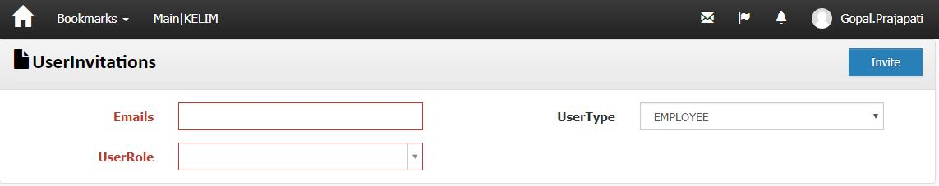
screenshotNo-011
Business Logic:

1)-Controller Name-> UserInvitationController: This controller has three Services for display Designation List.
a) IUserReferralService
b) IEmployeeService
c) IExceptionHandlingService
2)-Action Method:
Action Method Name :-> SendInvites: In this Action we get User invitation using GetUserEmail () method of UserInvitationController
3)-Entity Framework/Services->
Services Name: _UserReferralService →In this services we define GetUserEmail ().
DataLogic-
View Model Name/Model – UserReferral
Dependencies:
Data Access Layer
(UserReferralService)

Business Logic
(UserInvitationController)

Presentation Layer (View layer)
(SendInvites.chtml)

Work Flow: View → Controller →Model
View: SendInvites.chtml -> clearly us can see design of page
Controller: UserInvitationController
Model: UserReferral

